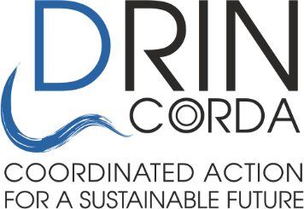
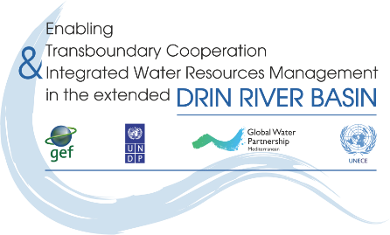

Signing Ceremony for the endorsement of the Drin Strategic Action Program
24 April 2020

Agenda

Time | Agenda Item
08.15 EDT (UTC-4)  14.15 CET (UTC +2)  15.15 EEST (UTC +3) | Log in to Meeting waiting room  Please log in by using the meeting code, through the Zoom desktop app  Please ensure the Zoom app is already downloaded and installed on your PC/Mac.  Please wait in the Zoom waiting room until admitted.
Drin Ministerial / High Level Meeting
08.30 / 14.30 / 15.30 hrs | Introduction to the Event and the Participants  Closed session | Mr Dimitris Faloutsos, Drin Project Coordinator / Deputy Regional Coordinator, GWP-Med
08.35 / 14.35 / 15.35 hrs | Report of the Secretariat of the Drin Core Group:  - Implementation of Drin Memorandum of Understanding  - The GEF/UNDP/GWP Drin Project  - The Drin Strategic Action Programme  - Follow up steps  Closed session | Mr Dimitris Faloutsos, Drin Project Coordinator / Deputy Regional Coordinator, GWP-Med
08.50 / 14.50 / 15.50 hrs | Feedback from the Drin Riparians  Closed session | Representatives of the Drin Riparians
Signing Ceremony
09.00 / 15.00 / 16.00 hrs | Introduction to the Event and the Participants - Statements by the Drin Riparians and Partners | Mr Dimitris Faloutsos, Drin Project Coordinator / Deputy Regional Coordinator, GWP-Med
 | - Ministry of Environment and Physical Planning, North Macedonia | H.E. Mr Jani Makraduli,  Deputy Minister
 | - Ministry of Environment and Energy, Greece | Prof. Konstantinos Aravossis,  General Secretary, Natural Environment and Water
 | - Ministry of Infrastructure and Environment, Kosovo | Mr Izedin Bytyqi,  Secretary General
 | - Water Resources Management Agency, Albania | Ms Gerta Lubonja,  General Director
 | - Ministry of Agriculture and Rural Development, Montenegro | Mr Momčilo Blagojević,  General Director, Directorate for Water Management
 | - Global Environment Facility | Mr Christian Severin,  International Waters Coordinator
 | - United Nations Development Programme | Mr Vladimir Mamaev,  Regional Technical Advisor, Water & Ocean Governance Programme,  Global Environmental Finance Unit
 | - United Nations Economic Commission for Europe | Mr Marco Keiner,  Director of Environment Division
 | - Global Water Partnership | Dr Monika Weber-Fahr  Executive Secretary & CEO
09.30 / 15.30 / 16.30 hrs | Signing the endorsement of the Drin Strategic Action Programme | Representatives of the Drin Riparians
09.35 / 15.35 / 16.35 hrs | Closing statements by the Representatives of the Drin Riparians and Partner Organizations
 | - GWP-Med | Prof Michal Scoullos, Chair
 | - UNECE | Mr Marco Keiner,  Director of Environment Division
 | - UNDP | Mr Limya Eltayeb, Resident Representatives of UNDP Albania Country Office  Ms Maria Suokko, UNDP Kosovo Country Office
 | - GEF | Mr Christian Severin,  International Waters Coordinator
 | - Drin Riparians | Ministers and High-level representatives
09.45 / 15.45 / 16.45 hrs | CLOSE

