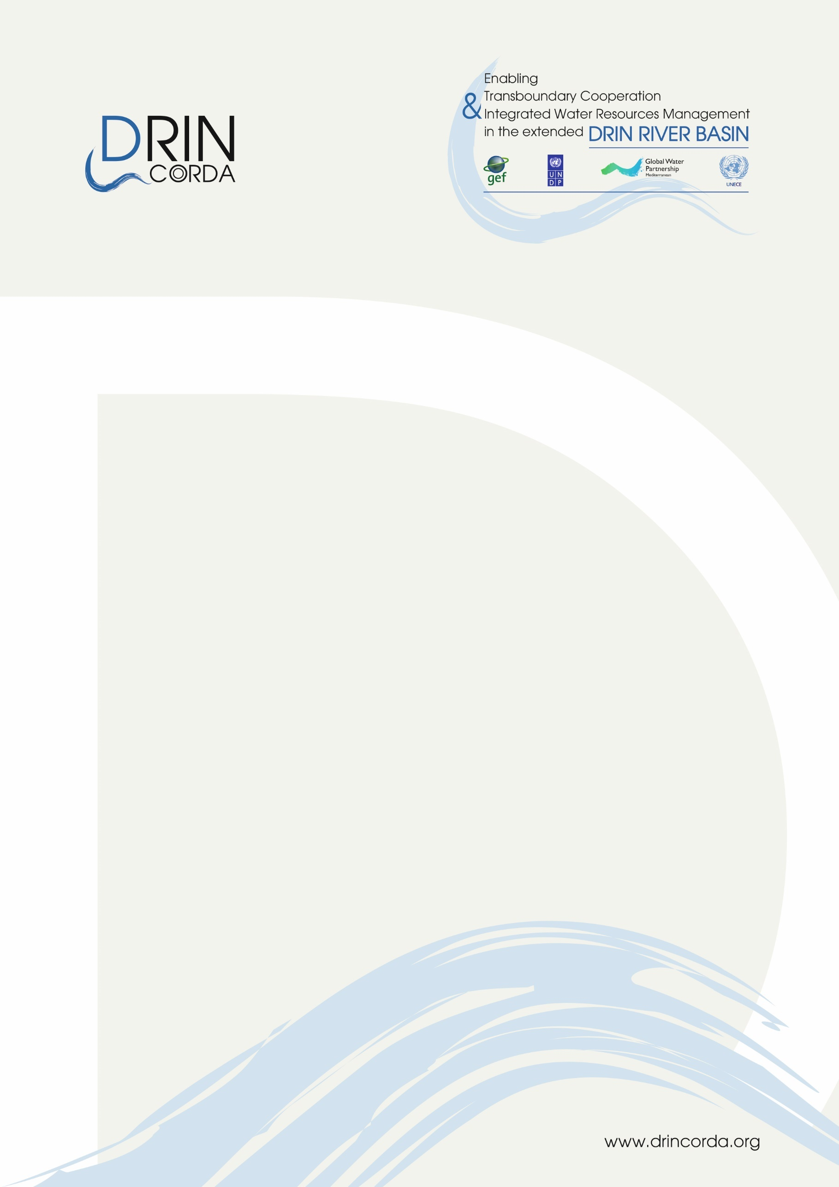

8th Stakeholder Conference

Friday, 9 July 2021

Agenda

In the framework of:

Memorandum of Understanding
for the Management of the Extended Transboundary Drin Basin

GEF Project “Enabling Transboundary Cooperation and Integrated Water Resources Management in the Extended Drin River Basin”

The on-line conference will review progress regarding the cooperation for the management of the Drin Basin and will discuss steps ahead.
The GEF Drin Project has been the main vehicle of support for the implementation of the 2011 Drin Memorandum of Understanding and pivotal in creating the conditions for closer cooperation among the Drin Riparians for the management of the Drin Basin. The operationalization of the Drin Core Group (DCG), constituting this the de facto joint coordination body, was -undoubtfully- the most significant result. The Strategic Action Programme -endorsed at Ministerial level on 24 April 2020- including the steps and actions to address the main transboundary problems identified through the Transboundary Diagnostic Analysis, are the key outputs of the GEF Drin project underpinning and carving the future course of action. The main outcomes achieved through this investment under the leadership and guidance of the Drin Riparians through the Drin Core Group, will be presented along with the opportunities it created for the future, to enhance cooperation and impactful action towards sustainable natural resources management.
In addition to the GEF Drin project, there have been significant interventions implemented with the support of donor countries, organizations and institutions that have been traditionally active in the Drin Basin area and its sub-basins. These interventions have contributed to addressing national priorities, and directly or indirectly in the implementation of the Drin Strategic Action Programme. These will be also presented during the web-based event.
The views of Drin Basin actors regarding the needs and opportunities for a cooperative and sustainable future for the Drin basin will be reflected in this partnership event.

Agenda

10:00 – 10:05 Welcome – Opening Remarks
- Mr. Dimitris Faloutsos, DCG Secretariat
10:05 – 10:30 Introductory statements
- Ministers and high-level representatives (tbc)
10:30 – 11:50 Session 1 - The Drin Coordinated Action
- Implementing the Drin MoU; results and steps ahead - The pivotal role of the GEF Drin Project
- Mr. Dimitris Faloutsos, DCG Secretariat
- Achievements and prospects – the views of the Drin Riparians
Representatives of the Drin Riparians will present their views regarding the present and future of cooperation for the management of the Drin Basin and the contribution of the Global Environment Facility supported project in this respect.
10:45 - 10:55 Mr. Arduen Karagjozi, Water Resources Management Agency, Albania
10:55 - 11:05 Ms. Evmorfia Alexopoulou, Ministry of Environment and Energy, Greece
11:05 - 11:15 Ms. Letafete Latifi, Ministry of Environment and Spatial Planning, Kosovo
11:15 - 11:25 Ms. Ivana Stojanovic, Ministry of Sustainable Development and Tourism, Montenegro
11:25 - 11:35 Mr. Ylbert Mirta, Ministry of Environment and Physical Planning, North Macedonia
- Achievements and prospects – the views of international organizations
11:35 - 11:40 Ms. Annuka Liponnen, Environmental Affairs Officer, UNECE
11:40 - 11:45 Mr. Vladimir Mamaev, Regional Technical Advisor, UNDP
11:45 - 11:50 Mr. Vangelis Constantianos, Executive Secretary/Regional Coordinator, GWP – Med

11:50 - 12:20 Questions and answers

12:20 - 13:00 Session 2 -Thematic and sectoral actions promoting basin management and transboundary cooperation
- Development partners active at the regional, basin and Riparian level briefly present the initiatives and projects they support

12:20 - 12:25 Representative of ADA (tbc)
12:25 - 12:30 Representative of GIZ (tbc)
12:30 - 12:35 Representative of Sida (tbc)
12:35 - 12:40 Representative of SDC (tbc)
12:40 - 12:45 Representative of KfW (tbc)
12:45 - 12:50 Representative of UNDP (tbc)
12:50 - 12:55 Representative of PONT (tbc)

- Moderated Panel Discussion
Representatives of the development partners will participate in a moderated “panel” discussion focusing on the on-going and future interventions and how these may contribute in the implementation of the Drin Strategic Action Programme and the enhancement of coordinated management of the Drin Basin. Questions from the participants will feed the discussion.

